K. SANJANA
2505A41L63
Q1. Palindrome Linked List
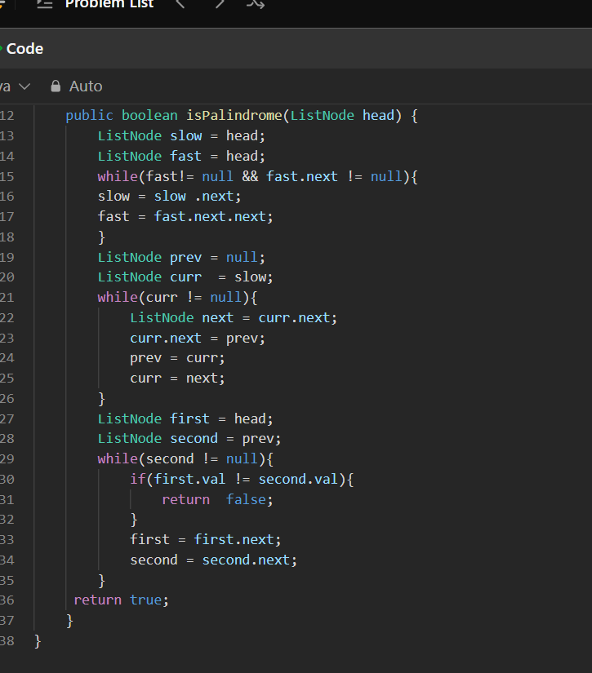
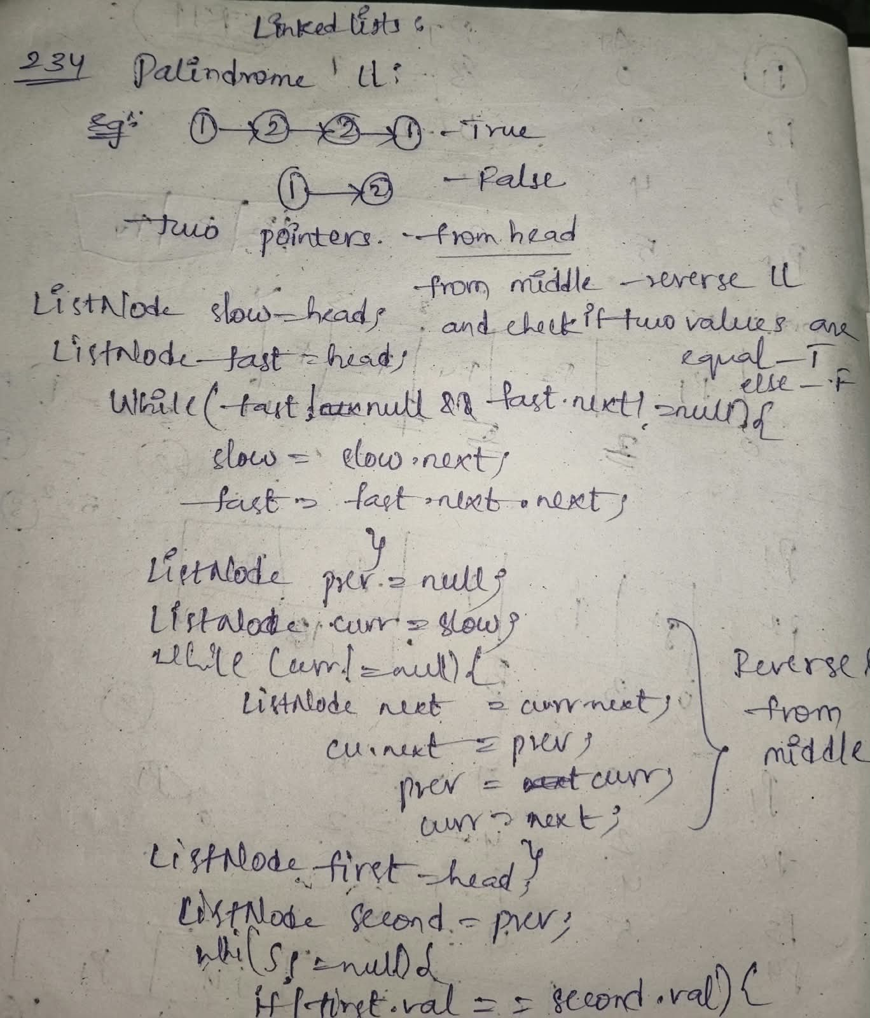
LeetCode Link: https://leetcode.com/problems/palindrome-linked-list/

Q2. Remove Duplicates from Sorted List
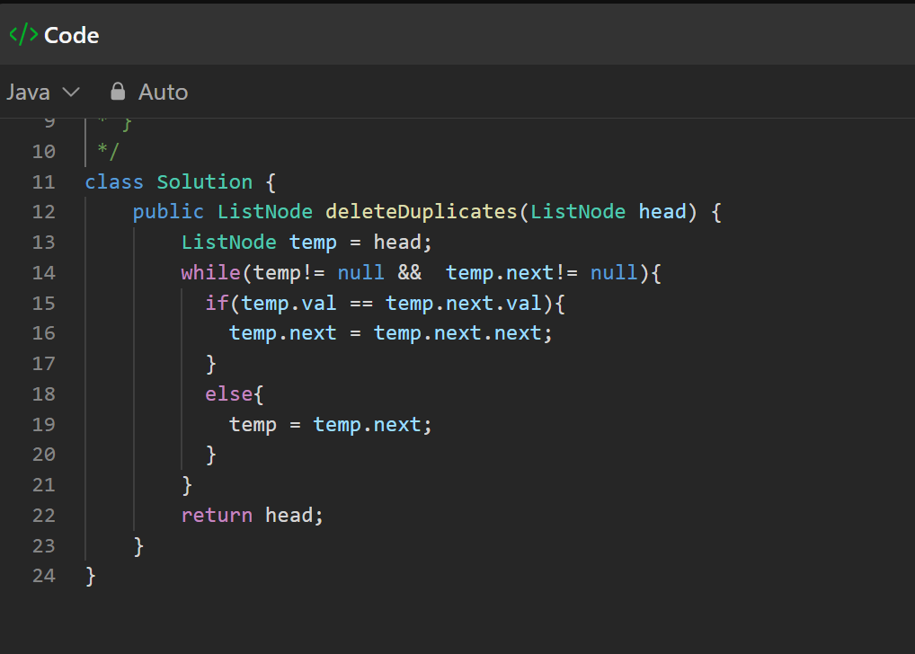
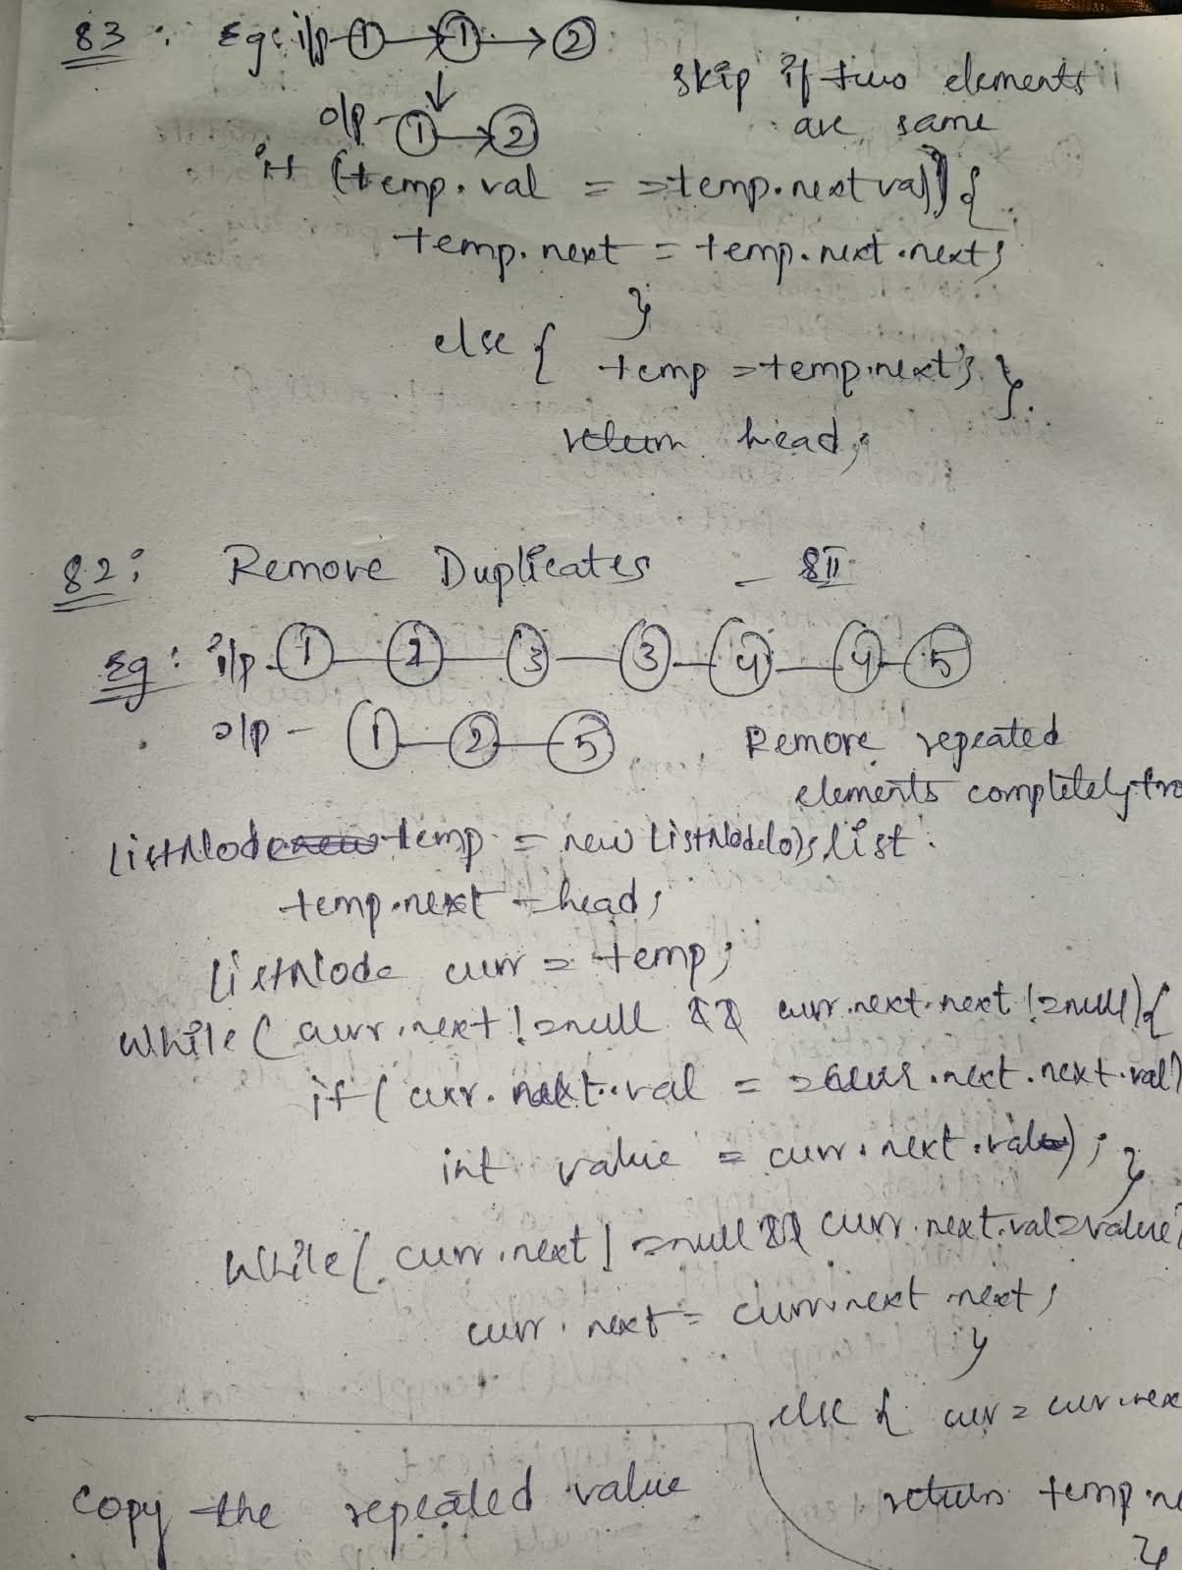
LeetCode Link: https://leetcode.com/problems/remove-duplicates-from-sorted-list/

Q3. Sort List
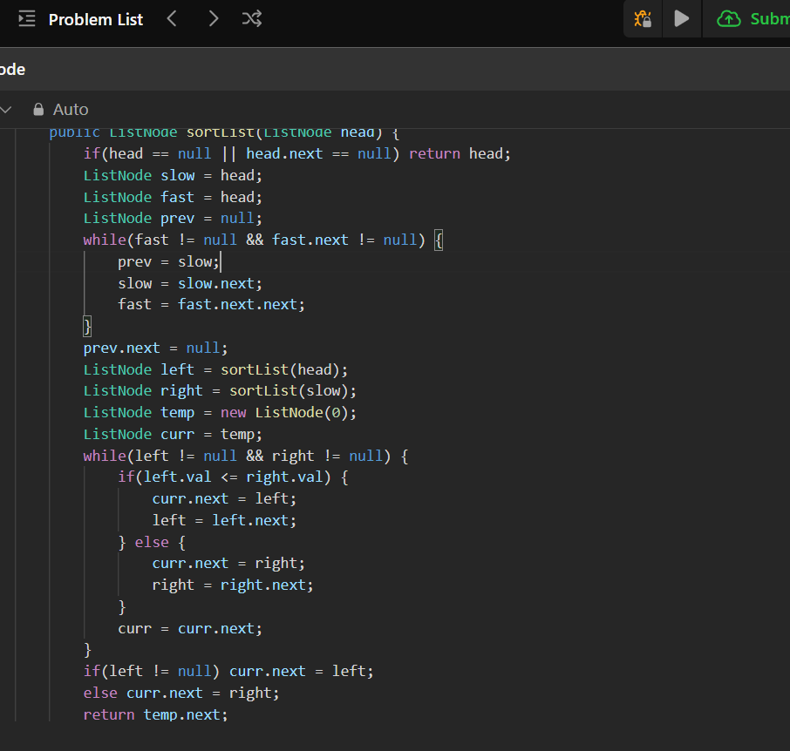
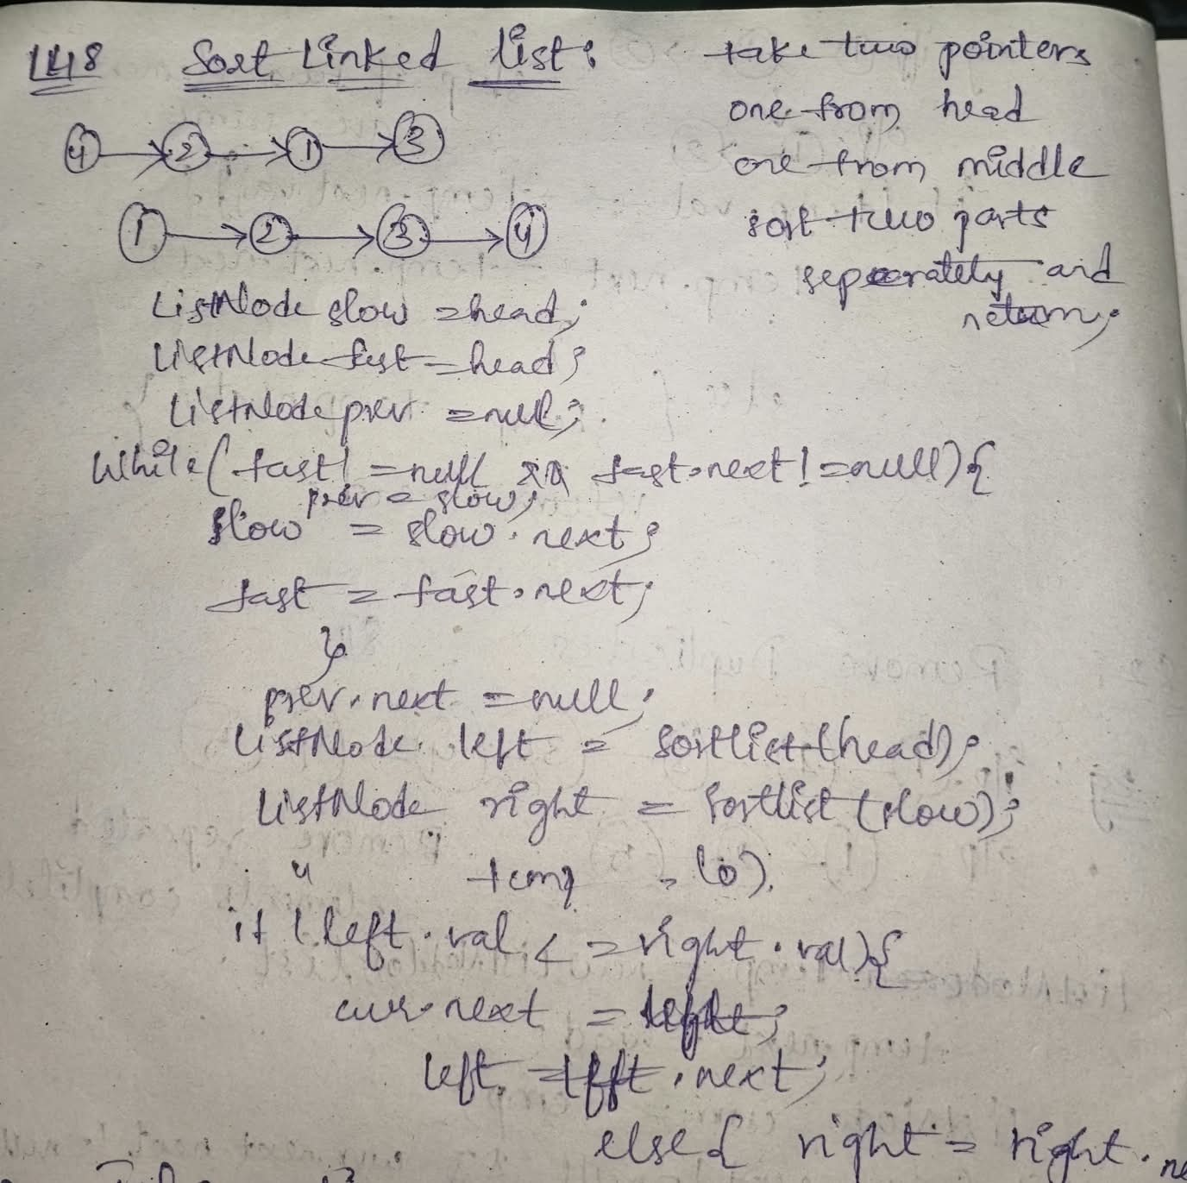
LeetCode Link: https://leetcode.com/problems/sort-list/

Q4. Copy List with Random Pointer
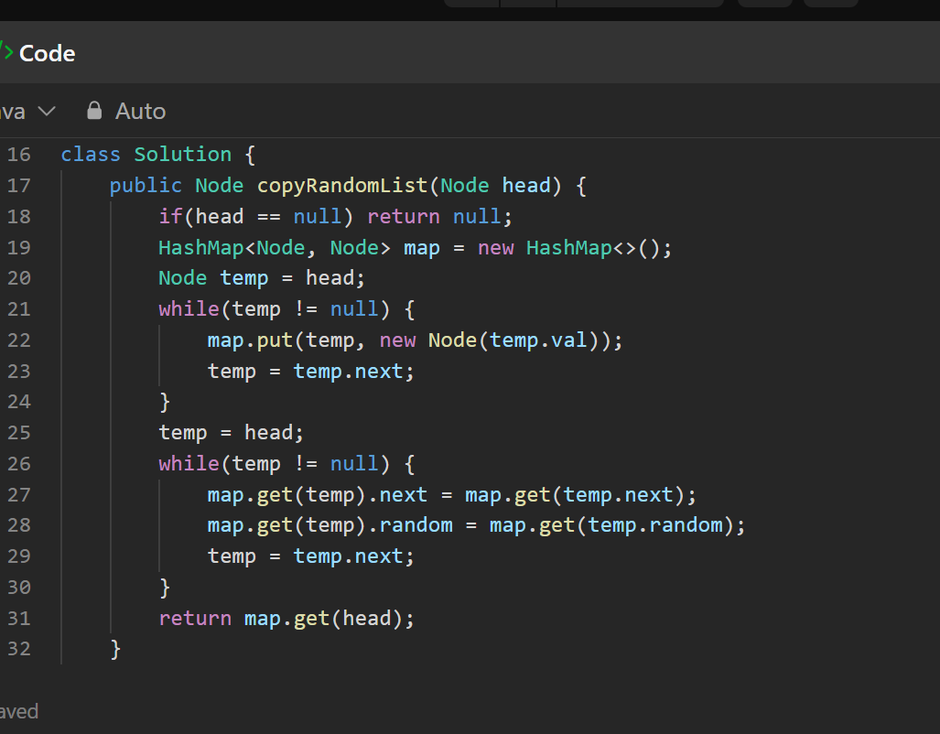
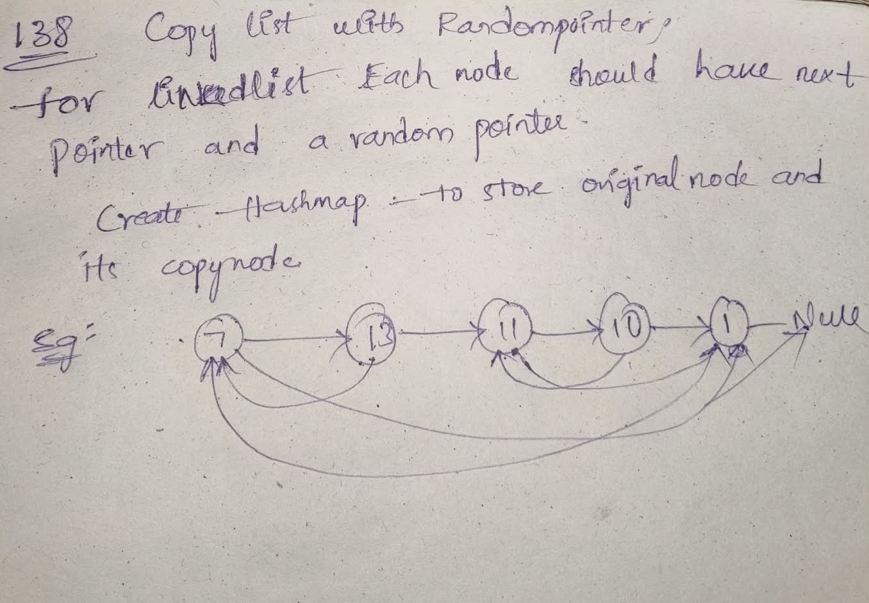
LeetCode Link: https://leetcode.com/problems/copy-list-with-random-pointer/

Q5. Intersection of Two Linked Lists
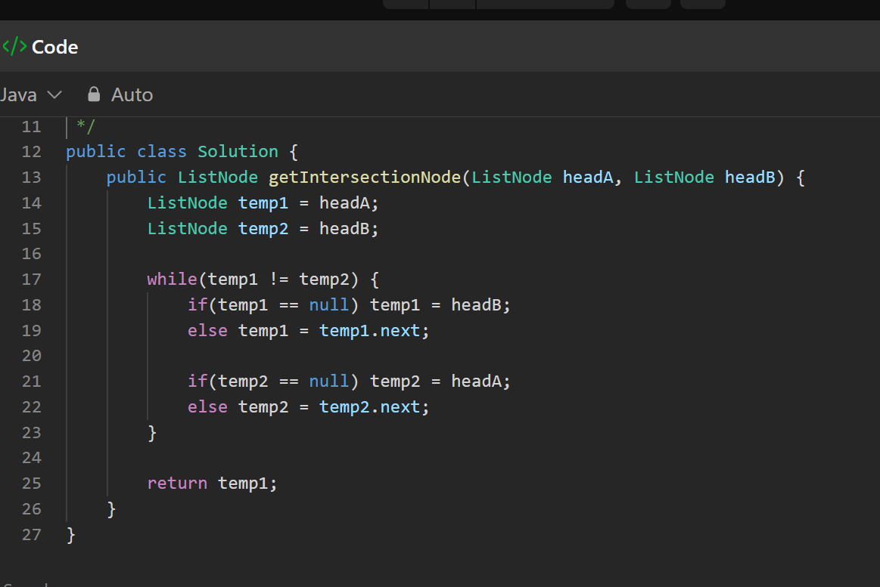
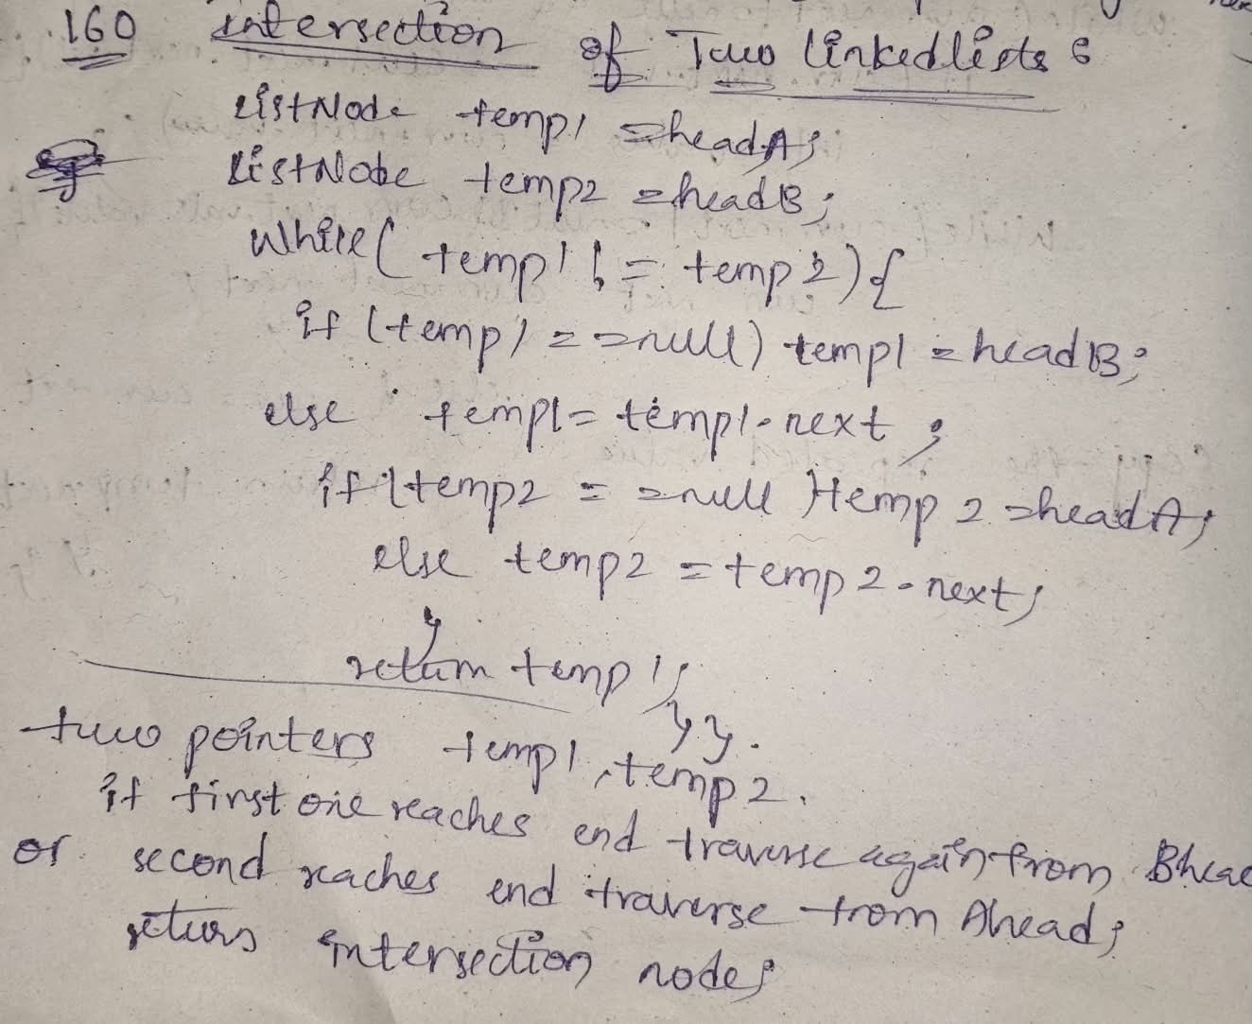
LeetCode Link: https://leetcode.com/problems/intersection-of-two-linked-lists/

